AP Statistics

Jared Derksen

Consultant #6865

November 8, 2014

LAUSD @ UCLA

**Agenda**

### Time Topic

### 8:00-10:00 Intro

CollegeBoard materials—advice to rookies

Movies and randomness

Class reunion #4

What I wish you said

10:00-10:15 Break

10:15-11:30 Grading/Creating the AP exam and FRQ #6

S.O.F.A., C.U.S.S.’ing & B.S.

Matching distributions activity

11:30-12:30 Lunch

12:30-1:45 Probability & Eggs #2

Simulating means-memory test

1:45-2:00 Break

2:00-3:00 Matched Pairs #5

Power dominoes

Teaching tips and test prep

Goals

* Participants will increase their knowledge about what a quality AP Statistics should offer.
* Participants will learn new activities that enrich their AP Statistics classes.
* Participants will improve their statistical knowledge.

Outcomes

* Participants will be equipped to deepen their students’ understanding of statistical concepts.
* Participants will have developed techniques for assessing their students’ communication of statistical ideas and tools for improving student skills in communication.
* Participants will implement statistical activities in their classroom that deepens statistical understanding.
* Participants will instruct their students in long-run simulations.

# Equity & Access

The College Board and the Advanced Placement Program encourage teachers, AP Coordinators, and school administrators to make equitable access a guiding principle for their AP programs. The College Board is committed to the principle that all students deserve an opportunity to participate in rigorous and academically challenging courses and programs. All students who are willing to accept the challenge of a rigorous academic curriculum should be considered for admission to AP courses. The Board encourages the elimination of barriers that restrict access to AP courses for students from ethnic, racial, and socioeconomic groups that have been traditionally underrepresented in the AP Program. Schools should make every effort to ensure that their AP classes reflect the diversity of their student population.

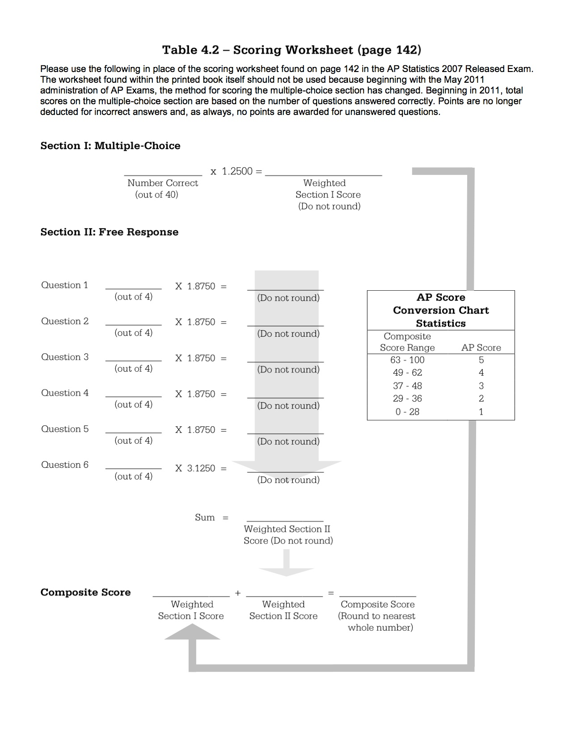

Be Specific! Clear Communication for Design

What You Said (**WYS**) vs. What I Wish You Said (**WIWYS**)

**WYS**: A control group will help us see the results.

**WIWYS**: A control group (with no music) will tell us a baseline of how much students learn. Then we can compare the music groups to that baseline.

**WYS**: If we block by gender, then we can see if boys do better than girls.

**WIWYS**: If we block by gender, we reduce the gender variability in study skills by having both genders represented equally in all treatment groups.

**WYS**: Yes. We can blind.

**WIWYS**: Yes. It is possible to have neither the subjects nor the evaluators know which treatment they are receiving.

**WYS**: Blinding will give us more accurate results.

**WIWYS**: Blinding will reduce any bias the evaluators may have in preferring one treatment to the other. It will also help isolate the placebo effect in the participants, as they will not know which treatment they are receiving.

**WYS**: Neighborhood would be confounding because some neighborhoods may have more headaches than others.

**WIWYS**: AND then we will mistakenly think that the treatment caused the increase in headaches, when in fact it was the neighborhood.

**WYS**: The wording of the question is biased. This will cause a response bias.

**WIWYS**: AND the wording will cause more people to say, causing an over-estimate of the parameter.

**WYS**: Rich people won’t want to be taxed and will say no.

**WIWYS**: That’s NOT a bias. That’s their opinion. Everyone has a reason for his or her opinion (and that’s ok).

**WYS**: Some people won’t want to answer our survey. That will cause non-response bias.

**WIWYS**: AND those people will be busy with real jobs and hate crime and want more prisons. So this will cause an under-estimate of those that will say Yes.

**Exploring data**

|  |  |  |
| --- | --- | --- |
| 1997 #1 | 2000 #3 | 2001 #1, 6a |
| 2002 #1 | 2002 B #5, 6c | 2003 #1ab |
| 2004 #1 | 2004B #5a | 2005 #1a, 2d |
| 2005B #1 | 2006 #1 | 2006B #1 |
| 2007 #1ab | 2007B #1 | 2008 #1 |
| 2008B #1a | 2009 #1ab | 2009B #1 |
| 2010 #6ab | 2010B #1 | 2011B #1 |
| 2012 #3a | 2013 #1a, 6 | 2013S #1a |
| 2014 #1ab, #4a | 2014S #1, 5a |  |

**Normal distribution**

|  |  |  |
| --- | --- | --- |
| 1998 #6a | 1999 #4 | 2000 #6d |
| 2002 #3a | 2003 #3ab | 2004B #3ab |
| 2005B #6b | 2006B #3ac | 2008B #5bc |
| 2009 #2a | 2011 #1 | 2013 #3a |
| 2014 #3a |  |  |

**Regression**

|  |  |  |
| --- | --- | --- |
| 1998 #2, 4 | 1999 #1, 6c | 2000 #1 |
| 2002 #4 | 2002 B  #1 | 2003 B  #1 |
| 2005 #3 | 2005B #5ab | 2006 #2ab |
| 2007 #6abde | 2007B #4 | 2008 #4ab, 6b |
| 2008B #6abd | 2010 #1b | 2010B#6abe |
| 2011 #5abc | 2011B #6ab | 2012 #1 |
| 2013S #4a | 2014 #6 |  |

**Transformations for linearity**

|  |  |  |
| --- | --- | --- |
| 1997 #6 | 2004B #1 | 2007B #6cd |
|  |  |  |

**Designing surveys and experiments**

|  |  |  |
| --- | --- | --- |
| 1997 #2 | 1998 #3 | 1999 #3 |
| 2000 #5 | 2001 #4 | 2002#2 |
| 2002 B #3 | 2003 #4 | 2003 B #3a |
| 2003 B #4abd | 2004 #2, 3d, 5b | 2005 #1bc, 5ac |
| 2004B #2, 6c | 2005B #3 | 2006 #5 |
| 2006B #5, 6f | 2007 #2, 5a | 2007B #3 |
| 2008 #2 | 2008B #4a | 2009 #3 |
| 2009B #4, 6a | 2010 #1a, 4c | 2010B #2 |
| 2011 #3 | 2011B #2 | 2012 #5c, 6a |
| 2013 #2, 5a | 2013S #3ab, 5c | 2014 #4b |
| 2014S #2 |  |  |

**Probability**

|  |  |  |
| --- | --- | --- |
| 1997 #3 | 1999 #5 | 2002 B #2 |
| 2003 B #2, 5a | 2004 #3bc, 4a | 2005B #6c |
| 2006 #3b | 2009B #2 | 2010B #5abc |
| 2011 #2, 6b | 2011B #3ab | 2014 #2ab, #3c |
| 2014S #4a |  |  |

**Random variables**

|  |  |  |
| --- | --- | --- |
| 1999 #5 | 2000#6bc | 2001 #2 |
| 2002 #3 | 2002 B #2 | 2003 B #5b |
| 2004 #4bc | 2004B #6b | 2005 #2abc |
| 2005B #2 | 2006 #3a | 2007B #2a |
| 2008 #3 | 2008B #5a | 2012 #2 |
| 2013 #3b | 2013S #3c | 2014S #4bc |

**Binomial/geometric & simulations**

|  |  |  |
| --- | --- | --- |
| 1998 #6bcde | 2001 #3 | 2003 #3c |
| 2004 #3a | 2005B #6d | 2006B #6c |
| 2007B #2b | 2008B #2 | 2009 #2b |
| 2010 #4ab | 2010B #3 | 2011B #3c |
| 2013 #5c | 2013S #6cd | 2014 #2c |

**CLT & Sampling Distributions**

|  |  |  |
| --- | --- | --- |
| 1998 #1 | 2004B #3cd | 2006 #3c |
| 2006B #3b | 2007 #3 | 2007B #2c |
| 2008B #3 | 2009 #2c | 2010 #2 |
| 2011B #6cd | 2013S #5ab | 2014 #3b |
| 2014S #6bcde |  |  |

**Inference with t for µ**

|  |  |  |
| --- | --- | --- |
| 1997 #5 | 1999 #6ab | 2002 B #6a |
| 2000 #2, 4 | 2001 #5 | 2002 #5 |
| 2003 #1c | 2003 B  #4 | 2004 #6 |
| 2004B #4, 5bc | 2005 #6 | 2005B #4 |
| 2006 #4 | 2006B #4 | 2007 #1c, 4 |
| 2007B #5 | 2008 #6a | 2008B #1b-3-4b-6c |
| 2009 #4, 6a | 2009B #5 | 2010 #5 |
| 2010B #4 | 2011 #4 | 2012 #3b, 6b |
| 2013 #1b | 2013b #1b | 2013S #1b |
| 2014 #5 | 2014S #3, 6a |  |

**Inference with z for p**

|  |  |  |
| --- | --- | --- |
| 1997 #4 | 1998 #5 | 2000 #6 |
| 2002 #6abd | 2002 B  #4 | 2003 #2, 6 |
| 2003B  #3b, 6 | 2004B #6a | 2005 #4, 5b |
| 2005B #6a | 2006B #2, 6abde | 2007 #5bcd |
| 2007B #6a | 2008 #4c | 2009 #5 |
| 2009B #3, 6b | 2010 #3 | 2011 #6a |
| 2011B #5 | 2012 #4, 5 | 2013 #5b |
| 2013S #2, 6ab |  |  |

**Chi-Square**

|  |  |  |
| --- | --- | --- |
| 1999 #2 | 2002 #6 | 2002 B #6b |
| 2003 #5 | 2003 B #5c | 2004 #5a |
| 2008 #5 | 2009 #1c | 2010B #5d |
| 2011B #4 | 2013 #4 | 2014 #1c |
| 2014S #5bc |  |  |

**Inference for Regression**

|  |  |  |
| --- | --- | --- |
| 2001 #6c | 2005B #5c | 2006 #2c |
| 2007 #6c | 2007B #6b | 2008 #6c |
| 2011 #5d | 2013S #4bc |  |

**Stretching into something new!**

|  |  |  |
| --- | --- | --- |
| 2006 #6 | 2008 #6d | 2009 #6bcd |
| 2009B #6cde | 2010 #6cde | 2010B #6cd |
| 2011 #6cd | 2011B #6ef | 2012 #6cd |
|  |  |  |

20XXS = 20XX Secure exam released in Audit

Compiled by Jared Derksen

Matching Boxplots, Histograms, & Summary Statistics

(By Sandi Takis, adapted from *Activity Based Statistics*)

Revised and reformatted by Kathy Fritz, Plano West Senior High School

* Copy the following pages on cardstock. They can be laminated to preserve them for future use.
* Have students work with a partner to match the boxplot, histogram, & summary statistics
* Provide each pair with a page to record the matches

Answers:

Histograms Boxplots Summary Statistics

I A 5

II C 1

III D 8

IV G 3

V E 2

VI F 6

VII B 4

VIII H 7

|  |  |
| --- | --- |
| Mean  3  50.08  Median  50  Standard Deviation  33.625 | 4  Mean  40.76  Median  38  Standard Deviation  21.171 |
| Mean  8  67.8  Median  74  Standard Deviation  17.049 | Mean  2  49.4  Median  50  Standard Deviation  20.265 |
| Mean  1  68.72  Median  71  Standard Deviation  30.019 | Mean  5  47.88  Median  41  Standard Deviation  19.020 |
| 7  Mean  52.32  Median  53  Standard Deviation  38.297 | 6  Mean  50.32  Median  50  Standard Deviation  16.163 |
|  |  |
|  |  |
|  |  |
|  |  |
|  |  |
|  |  |
|  |  |
|  |  |

Memory

Given 32 randomly selected numbers, volunteers are asked to memorize as many digits as they can in 30 seconds. Here are the results, separated by gender:

|  |  |  |
| --- | --- | --- |
| m | 12, 16, 13, 14, 13, 15, 19, 13, 15, 22 | mean(male) = 15.2 |
| f | 11, 14, 19, 19, 19, 15, 16, 9, 11, 11 | mean(female) = 14.4 |

1. Make a graphical display that shows the differences in the gender memorization skills. Describe your graph.

2. Do you think that this result shows that males are better at memorization than females? Explain.

3. Use 3x5 cards (shuffled) to create two different groups of 10 scores. (or use technology to do this!). What is the difference of the two means for a random shuffle?

4. With your classmates, gather at least 30 randomly created mean differences. Graph them below.

Macintosh HD:Users:mrmathman:Desktop:Screen Shot 2014-10-18 at 1.51.42 PM.png

5. Based on the results of the class simulation, do you think that the difference we observed is statistically significant? Explain.

37 93 85

97 13 72

42 31 28 21

98 83 25 94

92 30 12 69

63 99

20 40

60 54

61 55 24 11

70 62 88 45

Memory

*Suggested solutions*

Given 32 randomly selected numbers, volunteers are asked to memorize as many digits as they can in 30 seconds. Here are the results, separated by gender:

|  |  |  |
| --- | --- | --- |
| m | 12, 16, 13, 14, 13, 15, 19, 13, 15, 22 | mean(male) = 15.2 |
| f | 11, 14, 19, 19, 19, 15, 16, 9, 11, 11 | mean(female) = 14.4 |

1. Make a graphical display that shows the differences in the gender memorization skills. Describe your graph.

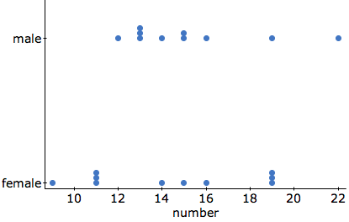

Females appear to have slightly lower scores than males. The male scores are skewed to the right.

2. Do you think that this result shows that males are better at memorization than females? Explain.

While the male average is slightly higher, it is not a very big difference. An average difference of 0.8 could just be random variation.

3. Use 3x5 cards (shuffled) to create two different groups of 10 scores. (or use technology to do this!). What is the difference of the two means for a random shuffle?

4. With your classmates, gather at least 30 randomly created mean differences. Graph them below.

5. Based on the results of the class simulation, do you think that the difference we observed is statistically significant? Explain.

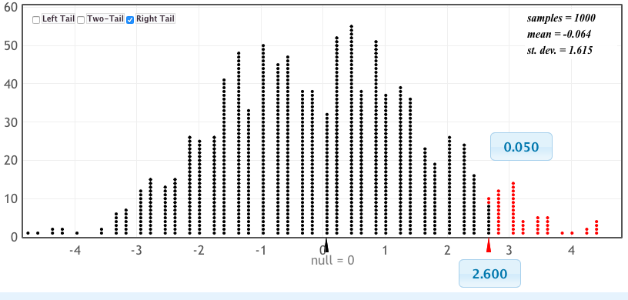

If the means were different by 2.6 or more, that would be very unusual and happen only 5% of the time. So a difference of 0.8 appears to the type of difference that could just happen by random chance.

# Inference Template Name:

Problem Number: ______ _______________

|  |
| --- |
| Name of Test/Interval: |
| Null and Alternative Hypotheses:  (in words and symbols) |
| Check of Conditions: |
| Math Box: (standard deviation, test statistic, p-value, margin of error, sketch, etc…) |
| Decision and conclusion: |

**Large-run simulations**

1998 #6 Pearl of unusual sizes

2009 #6 Simulating skewness

2010 #6 Simulated ranks

2013 #5c Difference of two proportions

2013S #6cd Power and p-value simulation

**Yawning Experiment**

Mythbusters ran an experiment to see if yawning is contagious. They had a room with a “yawn seed” where a planted person would yawn and then the others were observed to see if they yawned. In other rooms, there was no “yawn seed.”

Here’s the data:

|  |  |  |  |
| --- | --- | --- | --- |
|  | Treatment  (Yawn seed  Present) | Control | Total |
| Yes | 10 | 4 | 14 |
| No | 24 | 12 | 36 |
| Total | 34 | 16 | 50 |

On the show, they concluded that the yawn seed was successful. But was the difference really that large?

To simulate:

* Prepare decks of cards with 14 face cards and 36 non-face cards.
* The face cards represent the people who yawned.
* Students shuffle the cards.
* Count out 16 cards (control group).
* Count the number of face cards in the control.
* Make a dotplot.
* Online applet! <http://www.rossmanchance.com/applets/Yawning/Yawning.html>

**Froot Loops for Chis-square goodness of fit**

Materials

* 1 large box of Froot Loops per class
* cups or bowls to distribute cereal

The Plan

Students are given a small bowlful of cereal. They tally the color distribution of their data.

Color distribution is entered into a list.

Students are asked if the color distribution is uniform. They enter the expected distribution of uniform color distribution in a second list.

Problems with running multiple proportion tests are discussed. (insert Green Jelly Beans xkcd)

Chi-square goodness of fit test explained, run and written on inference template.

**Trends**

Trend and variation (TeddyTVNorge)

<http://www.youtube.com/watch?v=e0vj-0imOLw>

**Useful Links**

<http://apcentral.collegeboard.com/apc/public/courses/teachers_corner/2151.html>

<https://apscore.collegeboard.org/scores>

<http://www.collegeboard.com/html/apcourseaudit/>

<http://apstatsmonkey.com/StatsMonkey/Statsmonkey.html>

<http://www.mrmathman.com/faq>

*Stats Modeling the World-*Multiple Choice sort and applet list

<http://wps.aw.com/aw_bock_statsmodworld_4/> (click on Teacher Resources)

Great applets

<http://www.rossmanchance.com>

Free instructor’s software, $5/student

<http://www.statcrunch.com>

Totally free software!

<http://lock5stat.com/statkey/index.html>Exploratory Data Analysis project

Data

You must submit a proposal describing how your idea.

Quantitative data

Broken into at least 2 categorical groups

with at least 40 observations in each group.

Each group needs sufficient variability so that shape is evident

(e.g., “How many siblings do you have?” is a lousy question.)

You may gather the data from any source. Interviews, the Internet, etc…

Writing

1st paragraph: How and where you collected your data

2nd paragraph: By studying graphs of the data, what relationships can be observed?  What do the graphs show?  What conclusions can be drawn? Make sure to include Outlier checks and summary statistics.

Graph your data

* By hand, neatly, is fine
* Make TWO pairs of graphs for the quantitative data—histogram, boxplot, stemplot and/or dotplot

Details

Title page?—please, no.

Report cover?—spare my back

Poster?—not ‘til chapter 12

Size?—All paper to be 8.5” x 11”

This website, http://lock5stat.com/statkey/ will make your graphs pretty, if technology is your thing. Excel is not an option.

**Stats Project**

**Bringing it all together!**

1. **Report Proposal (10 points)**  Due date: _______

Your question of investigation, how you plan on getting your data and your population of interest. After you turn it in, I will help you fine-tune your idea until you have an AP caliber idea.

1. **Data Report (35 points)** Due date: _______

This section should be a thorough explanation of how you collected your data and be a beautiful example of how much you’ve learned this year about the difficulties getting a representative sample. Examples of what you should include are:

* How you collected your data
* Why you are confident your sample matches your population
* Biases avoided and not avoided
* A copy of any survey that was filled out
* A description of who you think your results generalize to
* Your data: either in “Excel” format or in a table/matrix summary.

1. **Exploring the Data (35 points)** Due date: _______

* This section should be an outstanding example of exploratory data analysis (the first unit in our text). Graphs should show the comparisons between all relevant groups you are comparing. You should state any preliminary conclusions that can be drawn by using your eyeballs.
* Graphs and statistics of your data
* Descriptions of the graphs and statistics.
* Your graphs can be done by hand. They should be very neat. Your description should be typed.

1. **Analyzing the Data (35 points)** Due date: _______

Analyze your data using whatever method(s) is appropriate for your data. Your conclusion should be nicely written using all appropriate statistical support. Remember that confidence intervals can be a powerful method for comparing different groups.

* Hypothesis Test (with conditions checked) and/or
* Confidence Intervals (with conditions checked) and/or
* Regression
* Your Grand Conclusion!

1. **Analyzing other groups (35 points)**

You will analyze each other group’s projects on the very last days of class.

* Make your own copies of **anything you turn in**. Once you turn in one part of your report, I need to keep it, but you will still need it to finish the other parts.
* Please type your reports.

Group # ______ (no names)

Question of Investigation:

Population:

How the data was collected:

Here’s our data:

Quantitative Data is in calculator # _________

**OR**

Categorical data is listed below/attached:

Your Group # ______ Group # Being Analyzed: _____

I. To answer the question of investigation, what procedure(s) need to done? You might just need one procedure. Or, if the project analyzes multiple questions/variables, you might need more than one. Please list the name of each test/interval/regression, along with the groups being compared/analyzed:

|  |  |  |
| --- | --- | --- |
| *Num.* | *Name* | *Description* |
| Ex: | 2-mean t-test | mean of female GPA and mean of male GPA |
| 1. |  |  |
| 2. |  |  |
| 3. |  |  |
| 4. |  |  |
| 5. |  |  |

II. State the p-value **or** interval **or** regression results for each procedure:

III. Conclusion. What is the answer to the question of investigation, based on the result(s) above?

Teacher Notes for final project

In order to handle the paperwork side of this project, I take a crate with hanging files and put numbered tabs, one number per hanging folder. As a group starts to turn in their project, each part goes into their folder.

I photocopy the group information sheet on one color paper and the final exam/analyze other groups sheet on a different color.

When students fill out their information paper, they are not always helpful about how they write down their data. For example, they might disaggregate their data by gender, even though there is nothing in their question about gender differences. I do not correct this. I want the other groups analyzing the data to figure out how and what they have to do with the data presented.

When writing the proposal, students get confused about the question of investigation vs. the questions they will ask in their survey. I have to remind them frequently that their question of investigation starts with “I wonder…?”

When students take their final, I simply pull an information sheet out of a folder (which sticks out because its green) and hand it to them. If the data is in a calculator, I have my class calculators with big post-its on them indicating the group number. It is best to save the data in a group as well as in the Stat Editor. Then if a group messes up the data, you can rescue it by ungrouping the lists from the archive memory.

When students are finished analyzing a project, I put their analysis in the folder with the rest of the work for that project. That makes grading very quick as you have the project right there with the correct analyses and you can look over all the same answers quickly and give each group the points they earned.